3.6.1 Packet Tracer - Implement VLANs and Trunking
Addressing Table
Device | Interface | IP Address | Subnet Mask | Switchport | VLAN
PC1 | NIC | 192.168.10.10 | 255.255.255.0 | SWB F0/1 | VLAN 10
PC2 | NIC | 192.168.20.20 | 255.255.255.0 | SWB F0/2 | VLAN 20
PC3 | NIC | 192.168.30.30 | 255.255.255.0 | SWB F0/3 | VLAN 30
PC4 | NIC | 192.168.10.11 | 255.255.255.0 | SWC F0/1 | VLAN 10
PC5 | NIC | 192.168.20.21 | 255.255.255.0 | SWC F0/2 | VLAN 20
PC6 | NIC | 192.168.30.31 | 255.255.255.0 | SWC F0/3 | VLAN 30
PC7 | NIC | 192.168.10.12 | 255.255.255.0 | SWC F0/4 | VLAN 10  VLAN 40 (Voice)
SWA | SVI | 192.168.99.252 | 255.255.255.0 | N/A | VLAN 99
SWB | SVI | 192.168.99.253 | 255.255.255.0 | N/A | VLAN 99
SWC | SVI | 192.168.99.254 | 255.255.255.0 | N/A | VLAN 99

Objectives
- Part 1: Configure VLANs
- Part 2: Assign Ports to VLANs
- Part 3: Configure Static Trunking
- Part 4: Configure Dynamic Trunking

Background
You are working in a company that is getting ready to deploy a set of new 2960 switches in a branch office. You are working in the lab to test out the VLAN and trunking configurations that are planned. Configure and test the VLANs and trunks.

Instructions

Part 1: Configure VLANs
Configure VLANs on all three switches. Refer to the VLAN Table. Note that the VLAN names must match the values in the table exactly.
VLAN Table

VLAN Number | VLAN Name
10 | Admin
20 | Accounts
30 | HR
40 | Voice
99 | Management
100 | Native

SWA | 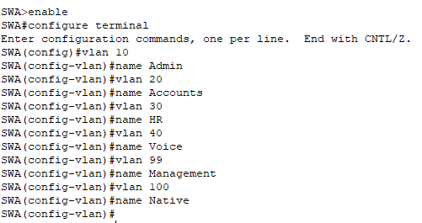  SWA>enable  SWA#configure terminal  SWA(config)#vlan 10  SWA(config-vlan)#name Admin  SWA(config-vlan)#vlan 20  SWA(config-vlan)#name Accounts  SWA(config-vlan)#vlan 30  SWA(config-vlan)#name HR  SWA(config-vlan)#vlan 40  SWA(config-vlan)#name Voice  SWA(config-vlan)#vlan 99  SWA(config-vlan)#name Management  SWA(config-vlan)#vlan 100  SWA(config-vlan)#name Native
SWB | 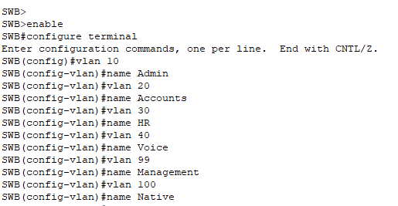  SWB>enable  SWB#configure terminal  SWB(config)#vlan 10  SWB(config-vlan)#name Admin  SWB(config-vlan)#vlan 20  SWB(config-vlan)#name Accounts  SWB(config-vlan)#vlan 30  SWB(config-vlan)#name HR  SWB(config-vlan)#vlan 40  SWB(config-vlan)#name Voice  SWB(config-vlan)#vlan 99  SWB(config-vlan)#name Management  SWB(config-vlan)#vlan 100  SWB(config-vlan)#name Native
SWC | 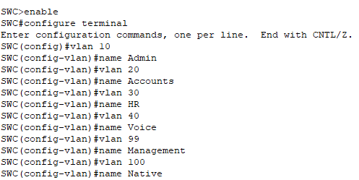  SWC>enable  SWC#configure terminal  SWC(config)#vlan 10  SWC(config-vlan)#name Admin  SWC(config-vlan)#vlan 20  SWC(config-vlan)#name Accounts  SWC(config-vlan)#vlan 30  SWC(config-vlan)#name HR  SWC(config-vlan)#vlan 40  SWC(config-vlan)#name Voice  SWC(config-vlan)#vlan 99  SWC(config-vlan)#name Management  SWC(config-vlan)#vlan 100  SWC(config-vlan)#name Native

Part 2: Assign Ports to VLANs

Step 1: Assign access ports to VLANs
On SWB and SWC, assign ports to the VLANs. Refer to the Addressing Table.

SWB | 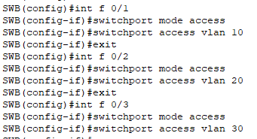  SWB(config)#int f 0/1  SWB(config-if)#switchport mode access  SWB(config-if)#switchport access vlan 10  SWB(config-if)#exit  SWB(config)#int f 0/2  SWB(config-if)#switchport mode access  SWB(config-if)#switchport access vlan 20  SWB(config-if)#exit  SWB(config)#int f 0/3  SWB(config-if)#switchport mode access  SWB(config-if)#switchport access vlan 30
SWC | 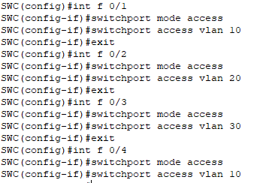  SWC(config)#int f 0/1  SWC(config-if)#switchport mode access  SWC(config-if)#switchport access vlan 10  SWC(config-if)#exit  SWC(config)#int f 0/2  SWC(config-if)#switchport mode access  SWC(config-if)#switchport access vlan 20  SWC(config-if)#exit  SWC(config)#int f 0/3  SWC(config-if)#switchport mode access  SWC(config-if)#switchport access vlan 30  SWC(config-if)#exit  SWC(config)#int f 0/4  SWC(config-if)#switchport mode access  SWC(config-if)#switchport access vlan 10

Step 2: Configure the Voice VLAN port
Configure the appropriate port on switch SWC for voice VLAN functionality.
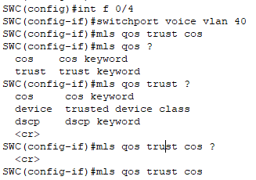
SWC(config)#int f 0/4
SWC(config-if)#switchport voice vlan 40
SWC(config-if)#mls qos trust cos

Step 3: Configure the virtual management interfaces
- Create the virtual management interfaces, on all three switches.
- Address the virtual management interfaces according to the Addressing Table.
- The switches should not be able to ping each other.

SWA | 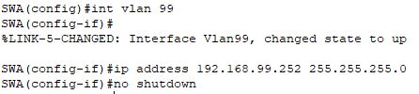  SWA(config)#int vlan 99  SWA(config-if)#ip address 192.168.99.252 255.255.255.0  SWA(config-if)#no shutdown
SWB | 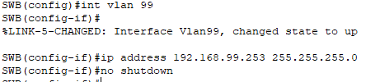  SWB(config)#int vlan 99  SWB(config-if)#ip address 192.168.99.253 255.255.255.0  SWB(config-if)#no shutdown
SWC | 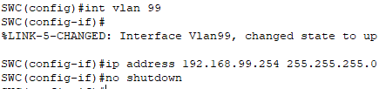  SWC(config)#int vlan 99  SWC(config-if)#ip address 192.168.99.254 255.255.255.0  SWC(config-if)#no shutdown

Part 3: Configure Static Trunking
- Configure the link between SWA and SWB as a static trunk. Disable dynamic trunking on this port.

SWA | 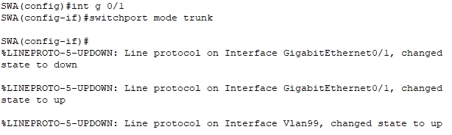  SWA(config-if)#int g 0/1  SWA(config-if)#switchport mode trunk
SWB | 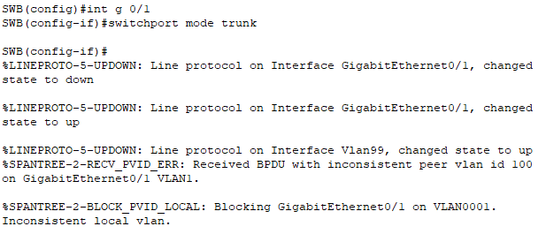  SWA(config-if)#int g 0/1  SWB(config-if)#switchport mode trunk

- Disable DTP on the switch port on both ends of the trunk link.

SWA | 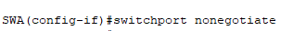  SWA(config-if)#switchport nonegotiate
SWB | SWB(config-if)#switchport nonegotiate

- Configure the trunk with the native VLAN and eliminate native VLAN conflicts if any.

SWA | 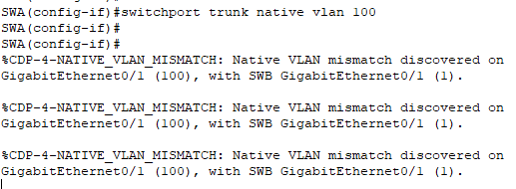  SWA(config-if)#switchport trunk native vlan 100
SWB | 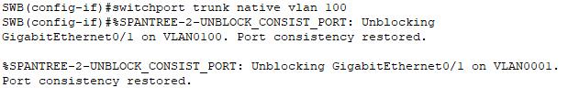  SWB(config-if)#switchport trunk native vlan 100

Part 4: Configure Dynamic Trunking
- Assume that the trunk port on SWC is set to the default DTP mode for 2960 switches. Configure G0/2 on SWA so that it successfully negotiates trunking with SWC.

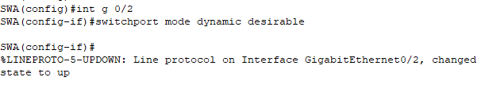
SWA(config)#int g 0/2
SWA(config-if)#switchport mode dynamic desirable

- Configure the trunk with the native VLAN and eliminate native VLAN conflicts if any.

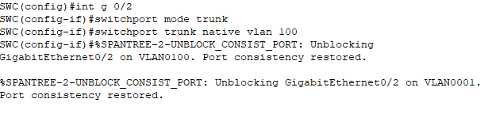
SWC(config)#int g 0/2
SWC(config-if)#switchport mode trunk
SWC(config-if)#switchport trunk native vlan 100
